**Que. 1**

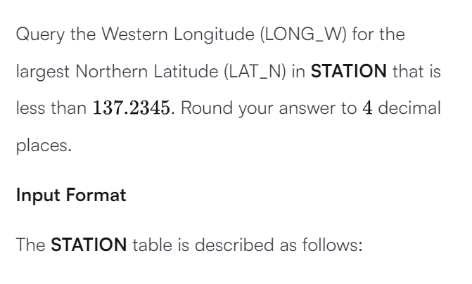

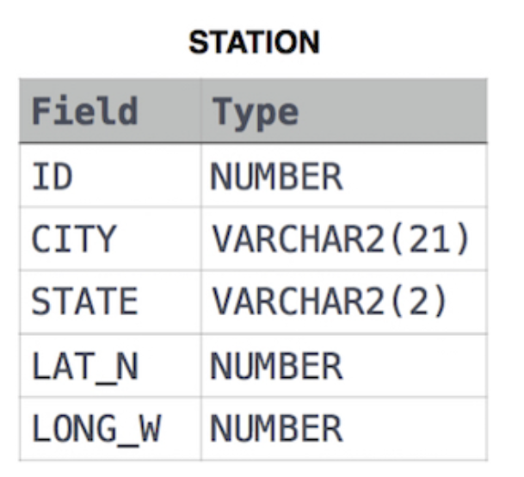

**Solution**:

**Que. 2**

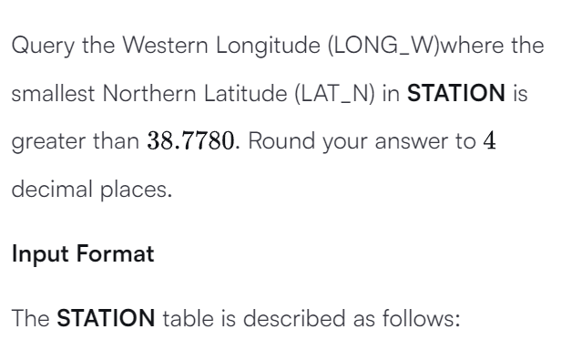



**Solution:**

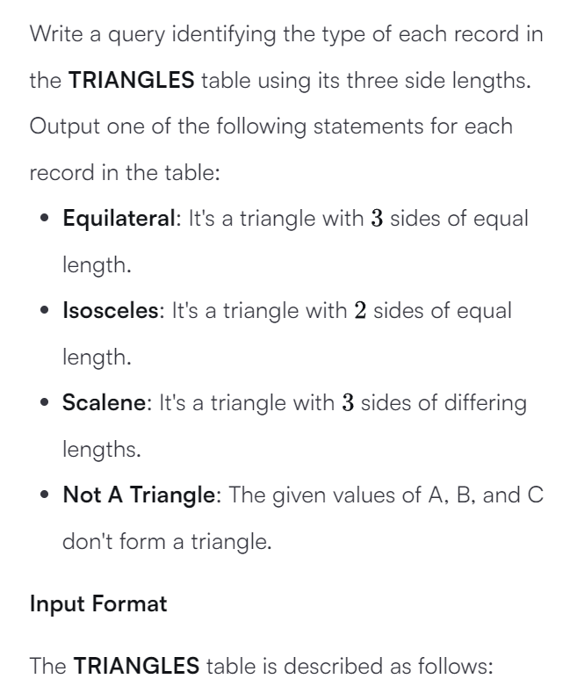**Que. 3**

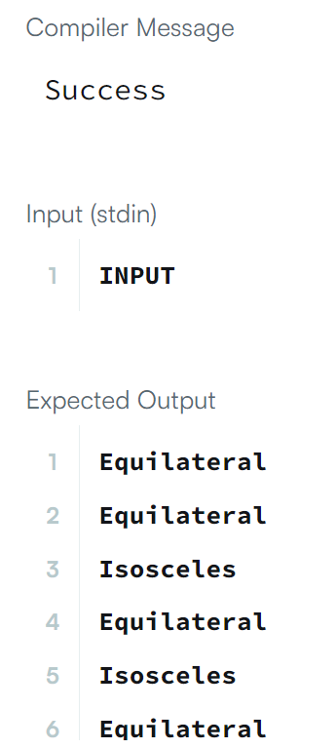**Solution**: